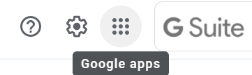 **Logging into Google Meet:**

1. Log into Google Mail using your Student Email Address.

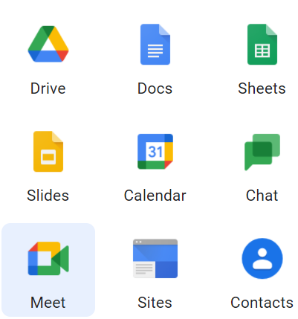2. Check your email and select the link to join Google Meet. Teachers will send a new link for each class.

3. Your child should be online for each video session scheduled, according to their timetable.

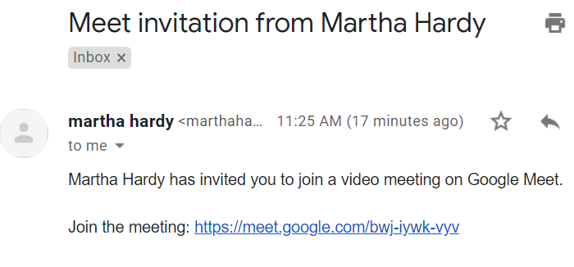

**Logging into Google Classroom:**

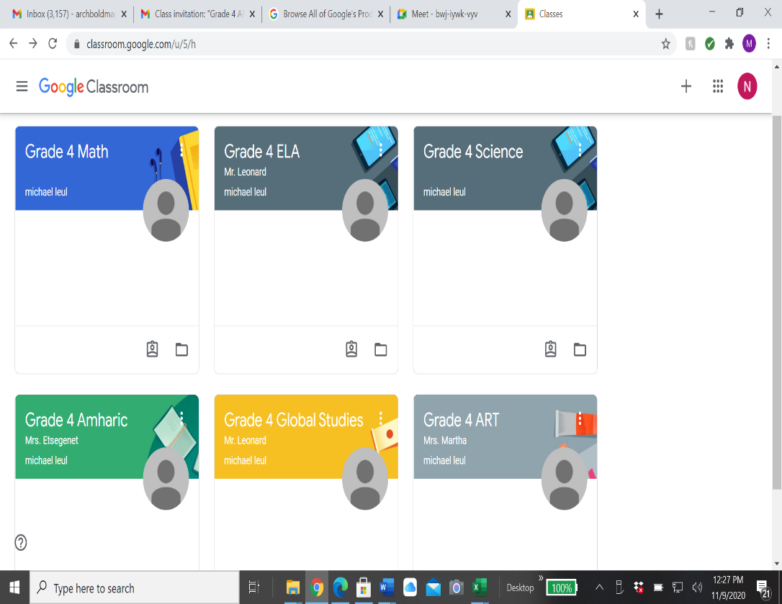1. Go to: classroom.google.com

2. Log in using your student Gmail account, and password

3. You will be admitted into your classroom, where each of your classes and assignments are listed.

4. To see and submit assignments, students can select the class icon and there they will see every activity they need to complete.